ASSIGNMENT – 2

Name – Tejasva Gupta
Enrollement no. – BTCS24O1137

Question 1.
Create a Java program using classes and objects to manage student information with methods for input and display.
Solution
import java.util.Scanner;

class Student {
int rollNo;
String name;
double marks;

// Method to input student information
void input() {
Scanner sc = new Scanner(System.in);

System.out.print("Enter Roll Number: ");
rollNo = sc.nextInt();

sc.nextLine(); // consume newline

System.out.print("Enter Name: ");
name = sc.nextLine();

System.out.print("Enter Marks: ");
marks = sc.nextDouble();
}

// Method to display student information
void display() {
System.out.println("\n--- Student Information ---");
System.out.println("Roll Number: " + rollNo);
System.out.println("Name: " + name);
System.out.println("Marks: " + marks);
}
}

public class StudentManagement {
public static void main(String[] args) {

Student s1 = new Student();

s1.input();
s1.display();
}
}

Ouput
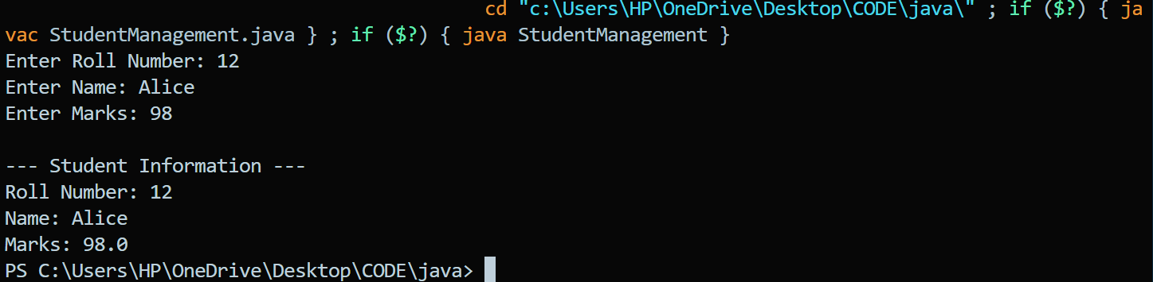
Question 2.
Implement constructor overloading and method overloading in a Java class.
Solution
class Student {

int rollNo;
String name;
double marks;

// Constructor 1: No arguments
Student() {
rollNo = 0;
name = "Unknown";
marks = 0.0;
}

// Constructor 2: Two arguments
Student(int rollNo, String name) {
this.rollNo = rollNo;
this.name = name;
marks = 0.0;
}

// Constructor 3: Three arguments
Student(int rollNo, String name, double marks) {
this.rollNo = rollNo;
this.name = name;
this.marks = marks;
}

// Method overloading - display()
void display() {
System.out.println("Roll No: " + rollNo);
System.out.println("Name: " + name);
System.out.println("Marks: " + marks);
}

// Overloaded display() method
void display(String message) {
System.out.println(message);
System.out.println("Roll No: " + rollNo);
System.out.println("Name: " + name);
System.out.println("Marks: " + marks);
}
}

public class OverloadingDemo {
public static void main(String[] args) {

// Constructor overloading
Student s1 = new Student();
Student s2 = new Student(101, "Rahul");
Student s3 = new Student(102, "Amit", 88.5);

System.out.println("Student 1:");
s1.display();

System.out.println("\nStudent 2:");
s2.display();

System.out.println("\nStudent 3:");
s3.display("Student Details:");
}
}

Output


